Read me for final project

Whole project is a combination of lab12 and lab13

1. Make sure the car is perfectly wired

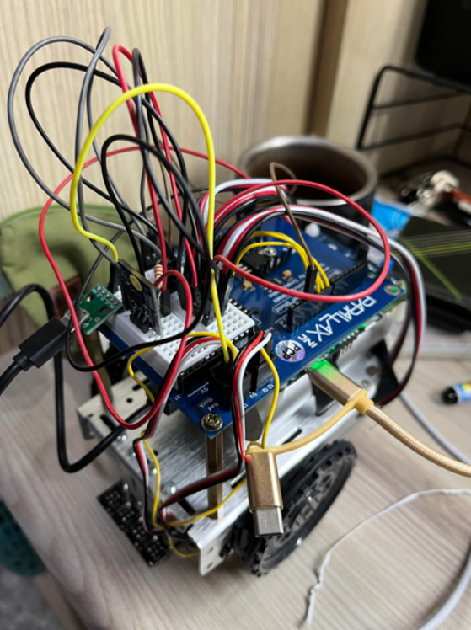

(remember to disconnect mbed board from pc for better performance)

1. Make sure all libraries are pushed

<https://gitlab.larc-nthu.net/ee2405_2022/bbcar.git>

<https://gitlab.larc-nthu.net/ee2405_2022/pwmin.git>

<https://github.com/ARMmbed/wifi-ism43362>

<https://gitlab.larc-nthu.net/ee2405_2022/paho_mqtt.git>

1. prepare a map composed of blacklines

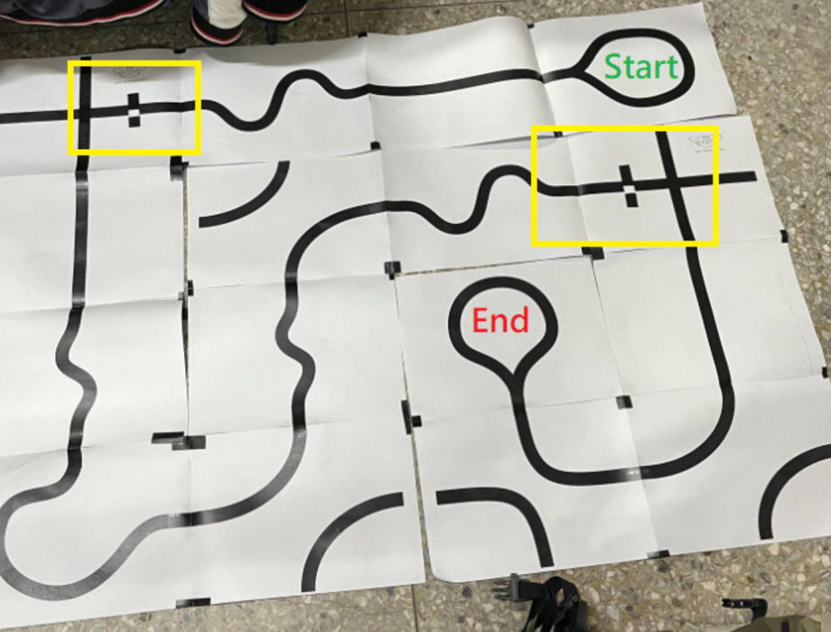

1. get the car connected to server
   * start sharing wi-fi from devices
   * open server, client from out devices
   * the BBcar will start operating once it is connected to server.
2. Observe the client window for task report from BBCAR.